SLOVAK UNIVERSITY OF TECHNOLOGY IN BRATISLAVA

FACULTY OF INFORMATICS AND INFORMATION TECHNOLOGY

**Gymbro**

Gym Companion

**Martin Szabo**

2023

Introduction

GymBro is an innovative and user-friendly application designed to simplify the process of finding the perfect gym for your fitness routine. GymBro offers a range of features and functionalities that cater to the needs of gym enthusiasts looking for a gym that fits their requirements.

1. Description

GymBro is a user-friendly desktop companion application designed for gym enthusiasts who want to find the best gym for their workout needs in their city. The app provides an interactive map displaying all the gyms in the area, which can be clicked to explore the following data:

* Gym equipment,
* User reviews,
* Photos of the gym and the surrounding area,
* Membership tiers and their respective prices,
* Gym timetable,
* Trainers working there,
* Workout session prices,
* An evaluation of the price-to-equipment ratio.

GymBro also provides users with estimated travel time to the gym from their current location, along with a Google Maps link showing the path from their location to the gym. The app also includes a time map, indicating how busy the gym is during open hours. Overall, GymBro is an essential tool for finding the perfect gym in your area, offering all the information you need to make an informed decision about where to work out.

1. 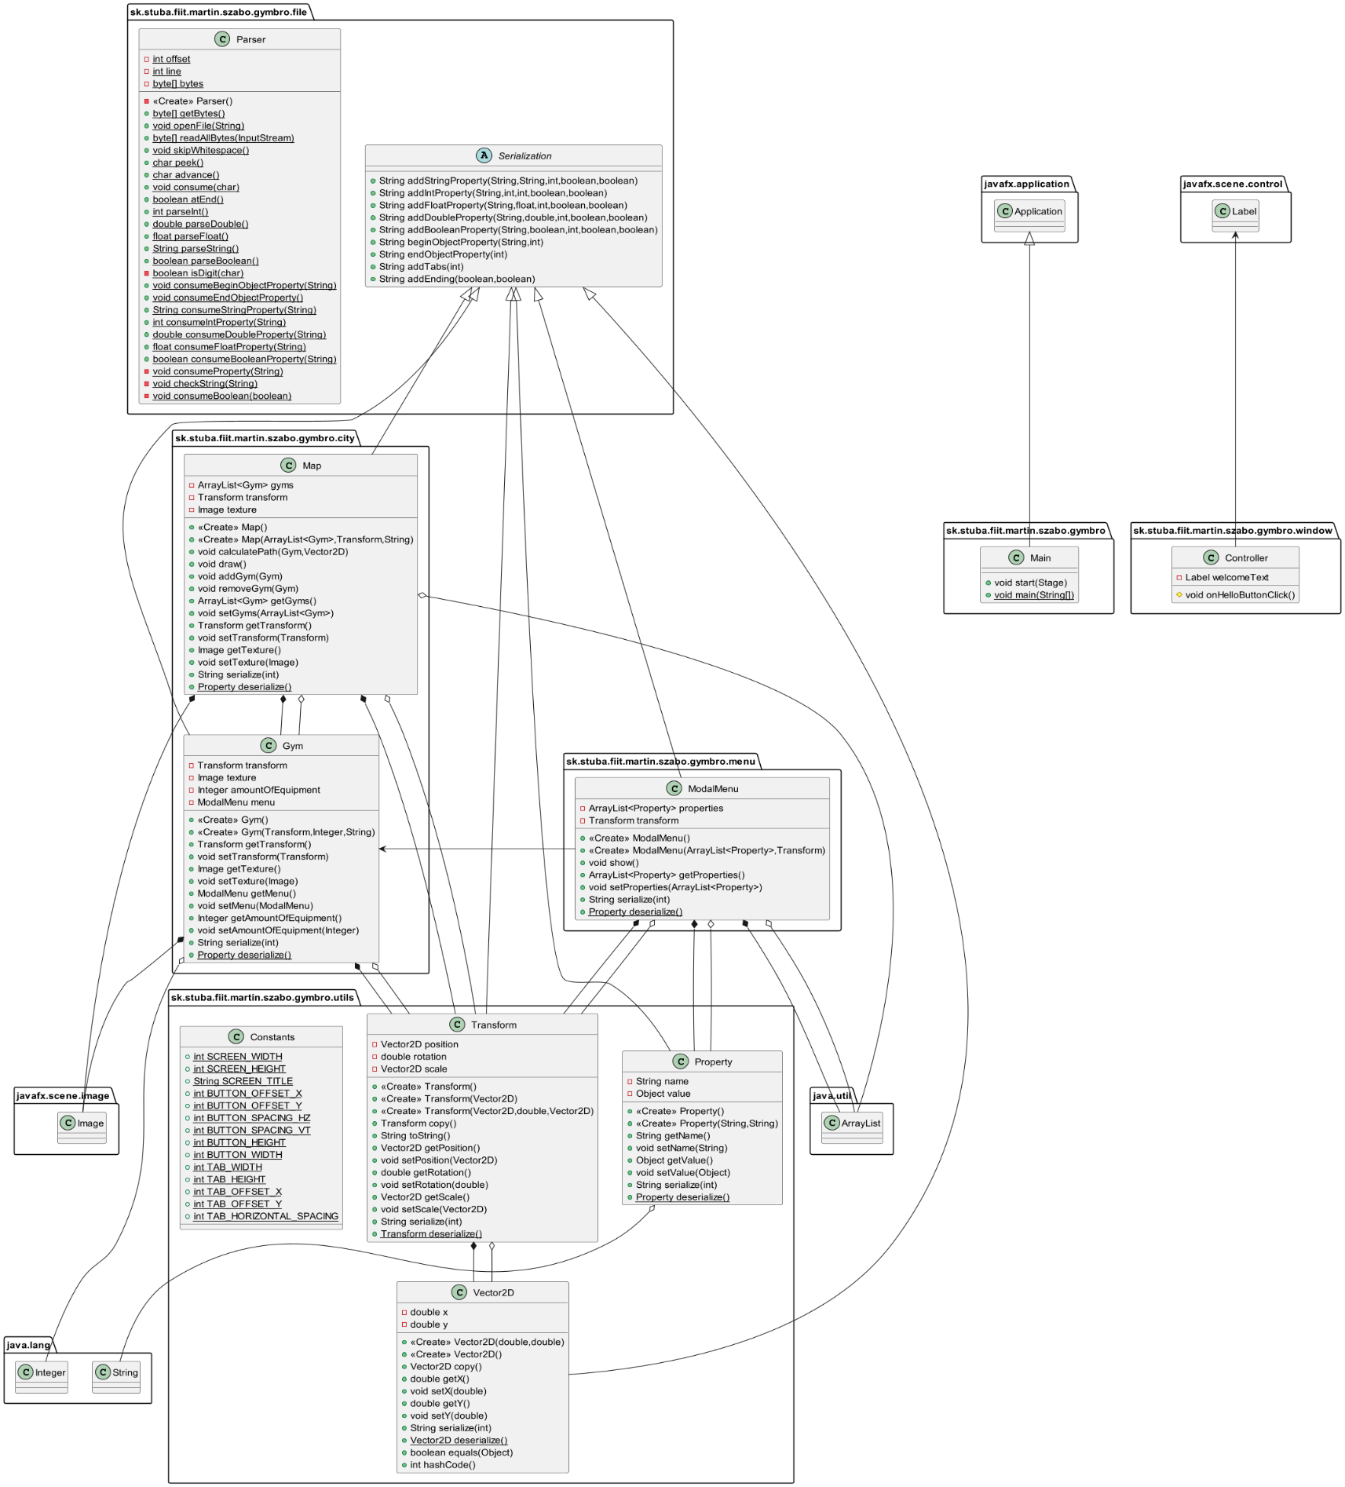Diagram